Data Aggregation

Hello Prof, since I already learned how to upload file to HDinsight in previous assignments and also because of my Azure account credits are running low. Thus, I want to save credits for the next module, like data visualization, I used MySql Workbench for this assignment, and it worked too.

1. Create 2 tables. The first table shows how many salespeople have attrition. Store this information in a column called “attrition”.

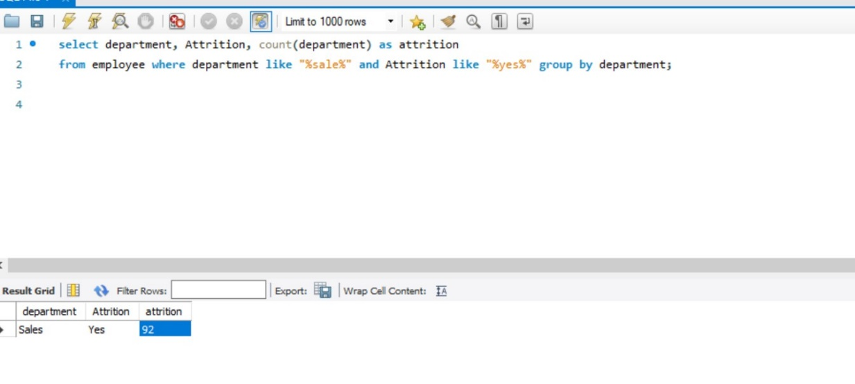

The second table with the column “non-attrition”

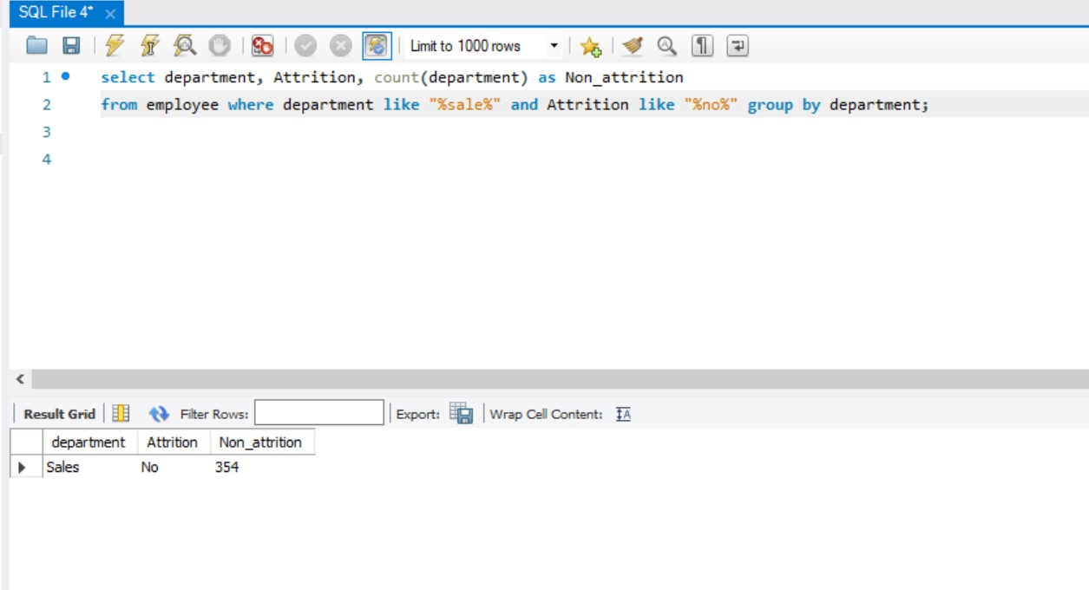

1. Create 3 statistics tables (average, min, max) showing the monthly income for: all salespeople, those with attrition and those without attrition. For each table, label the columns

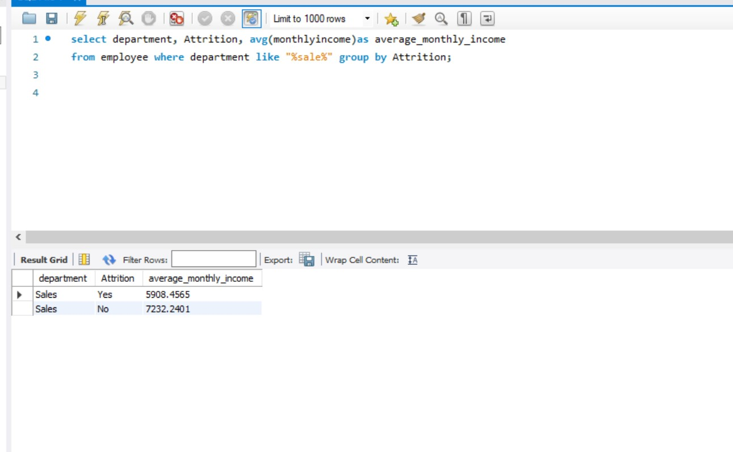

Min_monthly_Income

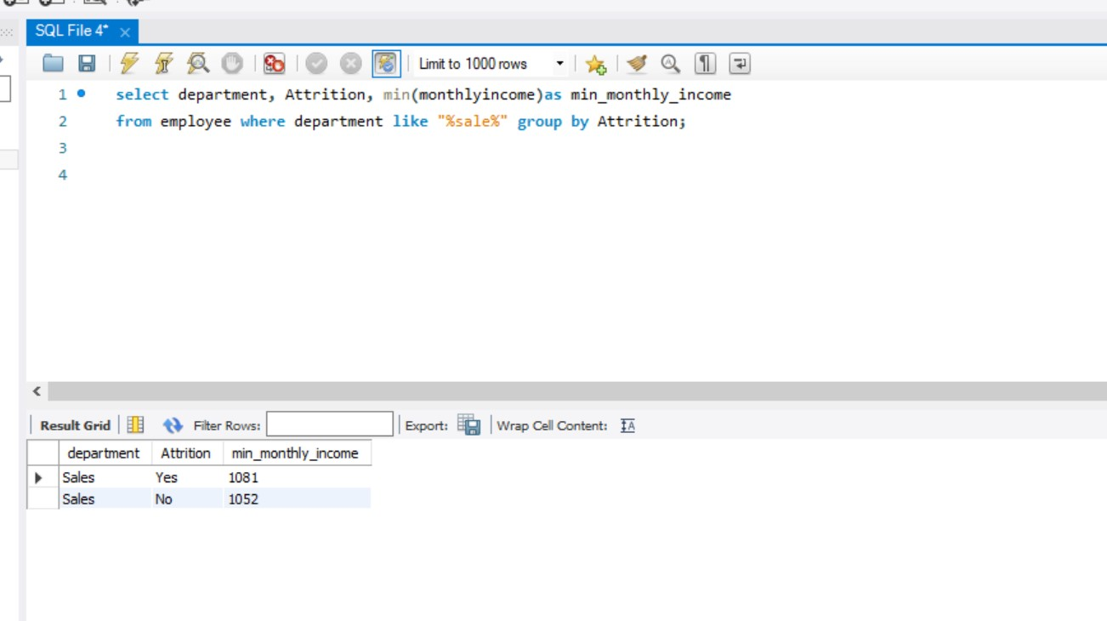

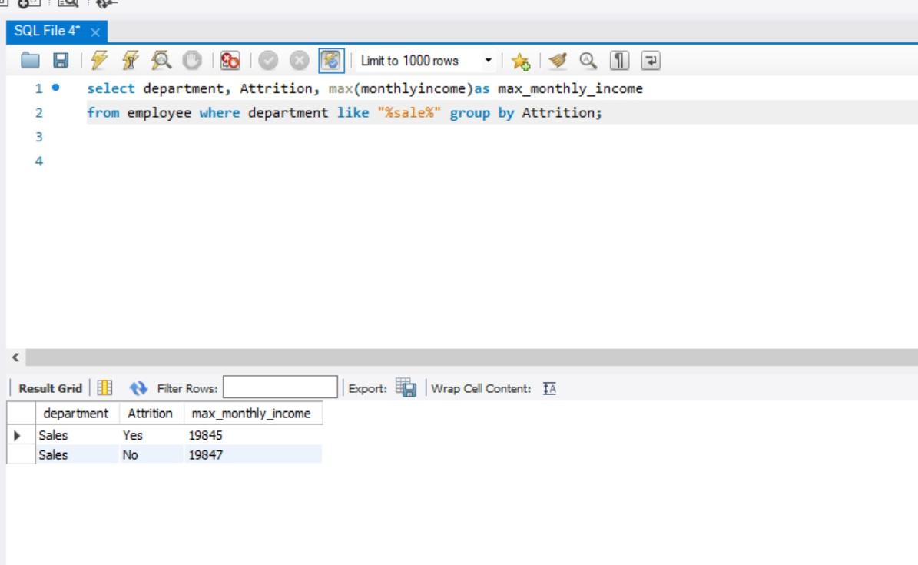

3) Create 2 tables containing the monthly income and count of salespeople making that monthly income for: salespeople with attrition and salespeople without attrition. Label the columns as: “monthlyincome” and “count”

